1.Analysis and Planning

<https://trello.com/invite/b/67594be1b6c83d6437b3c66d/ATTIa590d8c6a6f6d738d743cde7a1d69ba38ADC9FE1/1analysis-and-planning>

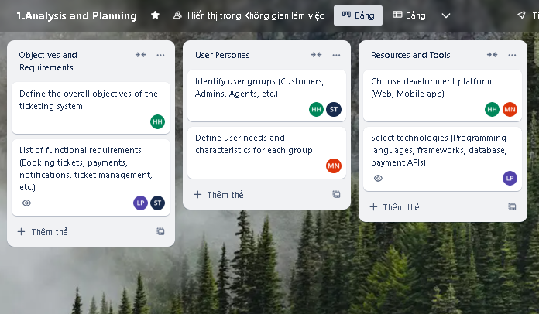

2.System Design

<https://trello.com/invite/b/67594c8b9fbd95740a805a68/ATTI97c06a02b01e5c8471f0b79dcb8a48e5FBA93CB6/2system-design>

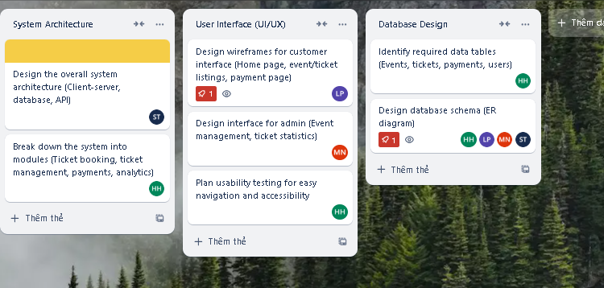

3.Development and Implementation

<https://trello.com/invite/b/67594cf6347bfaeccf74430a/ATTIe62b9956e650793cda2972e1d23d1507A52DF627/3development-and-implementation>

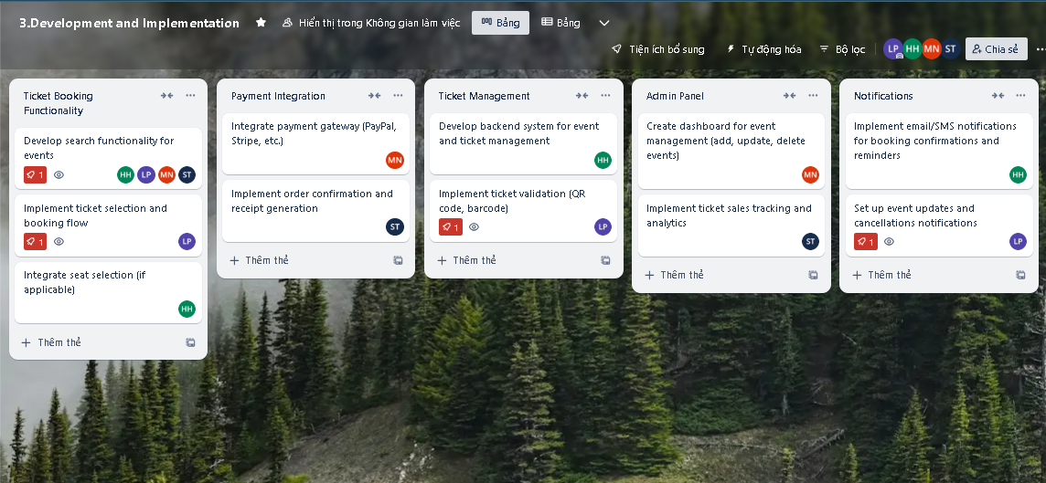

4.Testing and Deployment

<https://trello.com/invite/b/67594eee5e21e3e7b0d6fa63/ATTI573667360a3bef3f0de0da9e630151aeA922A30E/4testing-and-deployment>

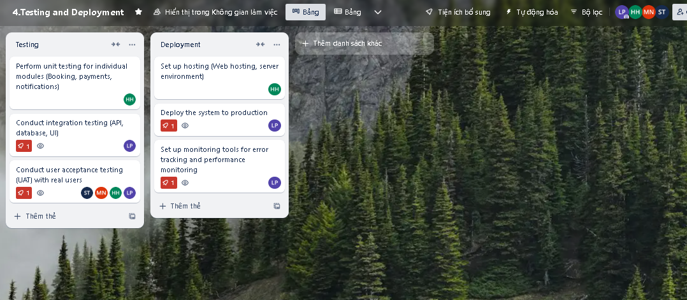

5.Post-Launch

